Contents

Introduction 1

Prerequisites 1

Capture a Linux Virtual Machine 1

Prepare the VM 1

Shutdown VM 2

Capture Image 2

Listing the New Image 2

Delete Image 2

# Introduction

The purpose of this document is to show the attendee how to capture a Linux virtual machine to be used as image when creating new machines. This can be useful when the machine has a setup that needs to be distributed over several machines (e.g. cloud computing).

## Prerequisites

The attendee needs a working Linux virtual machine. Create one for example with the command:

azure vm create <vm-name> <image-name> <username> --location <location> --ssh

As image, you can use an image for Ubuntu 12.04 LTS with the name

b39f27a8b8c64d52b05eac6a62ebad85__Ubuntu-12_04_2-LTS-amd64-server-20130624-en-us-30GB

# Capture a Linux Virtual Machine

## Prepare the VM

Connect to your virtual machine with an SSH client (CLI, Putty, …).

Once logged in with a user with sudo-rights, use the command:

sudo waagent -deprovision

This command will delete all SSH host key pairs, nameserver configuration and DHCP leases and disable root access. When asked, confirm this:

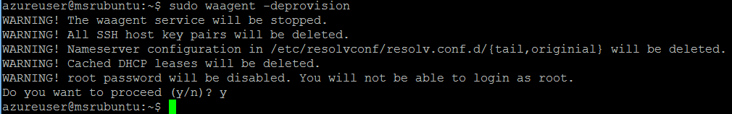

After this step, you will no longer be able to login to this virtual machine.

Close the SSH session with “Exit”.

## Shutdown VM

Open a shell to capture the virtual machine. Execute the following command:

azure vm shutdown <vm-name>

In case you forgot the vm name, you can always get it with

azure vm list

The output of shutting down the VM should look like this:

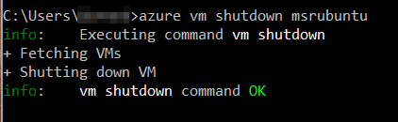

## Capture Image

The final step is to capture the VM image. In your console, use the command:

azure vm capture --delete <vm-name> <target-image-name>

This operation will capture the VM, store the image to <target-image-name> and (if successful) delete the VM. The delete flag is required.

The output of this operation should look similar to this:

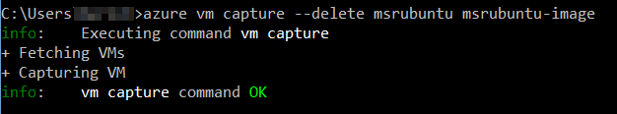

## Listing the New Image

Once the image is captured, you can use it to create new virtual machines. Check that your image is in the image gallery by executing the following command:

azure vm image list

You should find your image along the other available images:

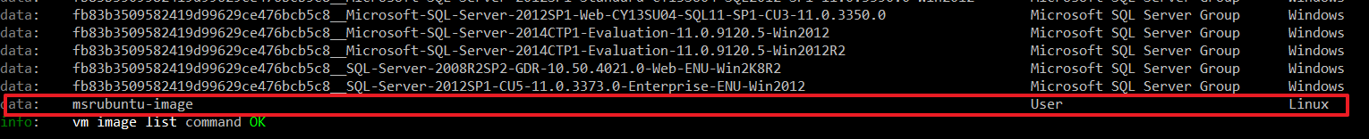

## Delete Image

You can delete an image not needed by executing the following command:

azure vm image delete msrubuntu-image

The output of this operation should look similar to this:

